1. Set up Shards

|  |  |  |  |
| --- | --- | --- | --- |
| Shard Controller | mongos | 27021 | N/A |
| Config Server | mongod | 27022 | /db/config/data |
| Shard0 | mongod | 27023 | /db/shard0/data |
| Shard1 | mongod | 27024 | /db/shard1/data |

1. Set up a config replica set

(a) Create a directory

vagrant@vagrant-ubuntu-trusty-64:~$ sudo mkdir -p /db/config/data

(b) Start a mongod serving as a config server

vagrant@vagrant-ubuntu-trusty-64:~$ sudo mongod --port 27022 --dbpath /db/config/data --configsvr --replSet config

(c ) In a new window, initialize the replica set

vagrant@vagrant-ubuntu-trusty-64:~$ mongo --port 27022

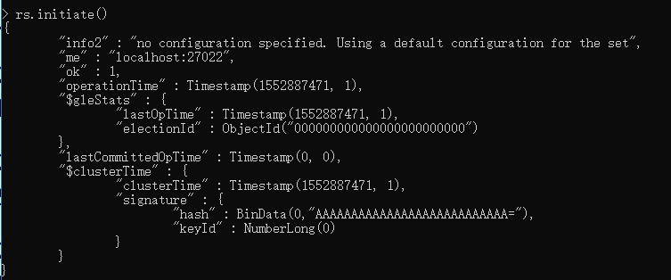

1. Set up the shard controller (mongos) in a new window

vagrant@vagrant-ubuntu-trusty-64:~$ mongos --configdb config/127.0.0.1:27022 --port 27021

Set the chunk size:

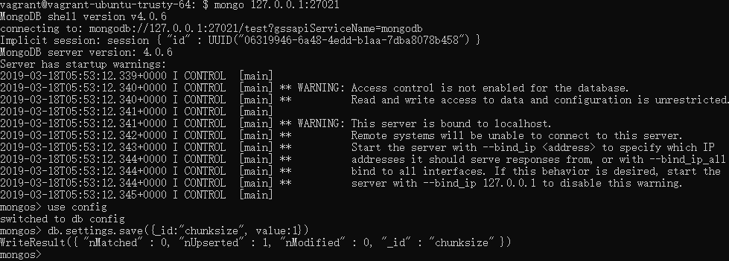

4. Bring up the two shard servers

(1) Open two new terminal, one for each server

vagrant@vagrant-ubuntu-trusty-64:~$ sudo mkdir -p /db/shard0/data

vagrant@vagrant-ubuntu-trusty-64:~$ sudo mongod –shardsvr --port 27023 --dbpath /db/shard0/data

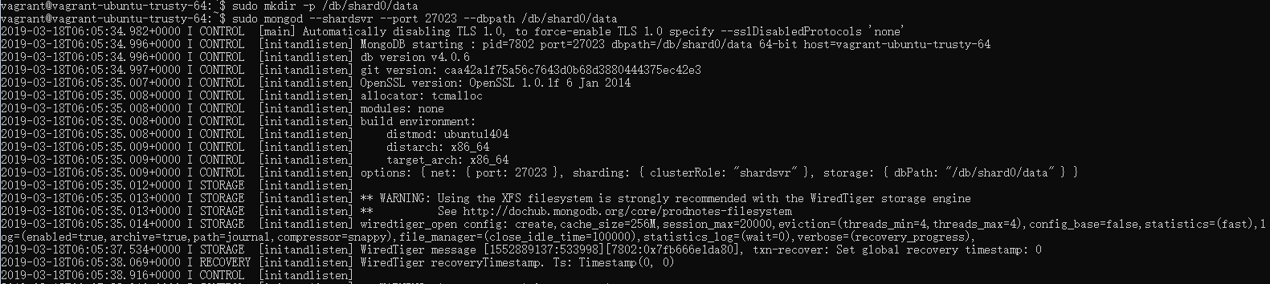

vagrant@vagrant-ubuntu-trusty-64:~$ sudo mkdir -p /db/shard1/data

vagrant@vagrant-ubuntu-trusty-64:~$ sudo mongod –shardsvr --port 27024 --dbpath /db/shard1/data

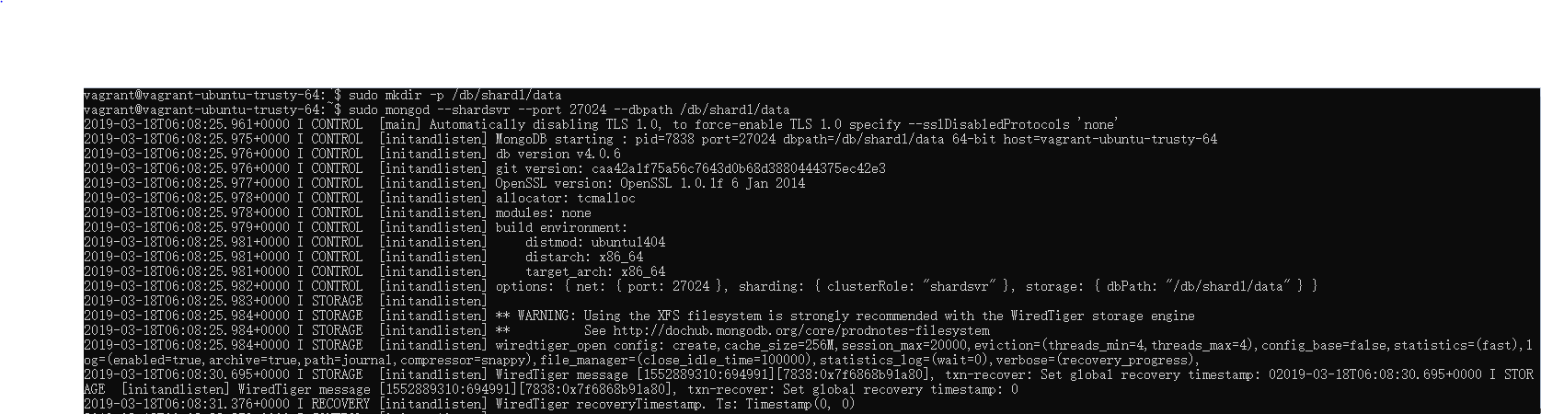

1. Tell the sharding system (mongos) where the shard servers are located. Check the shards:

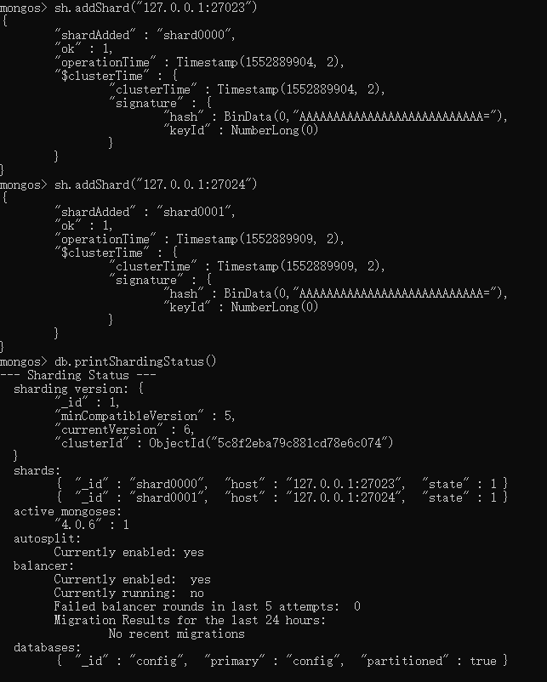

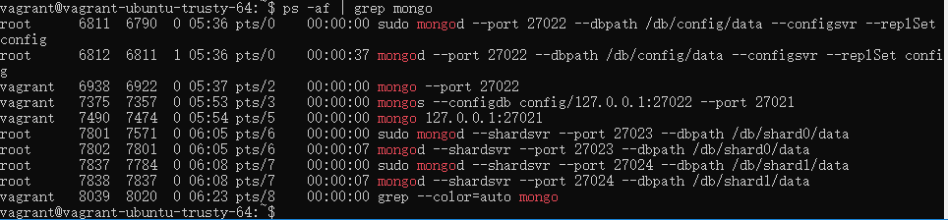

6. Explicitly tell both database and collection that you want them to be sharded.

1. Enabling a database for sharding is a prerequisite to sharding on of its collection
2. The given collection is going to be split into chunks.

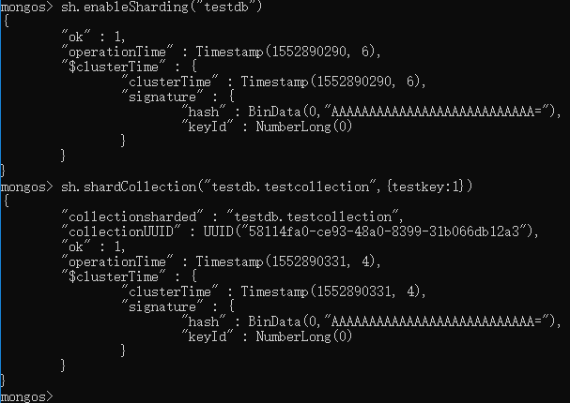

7. Populate data in testdb.testCollection

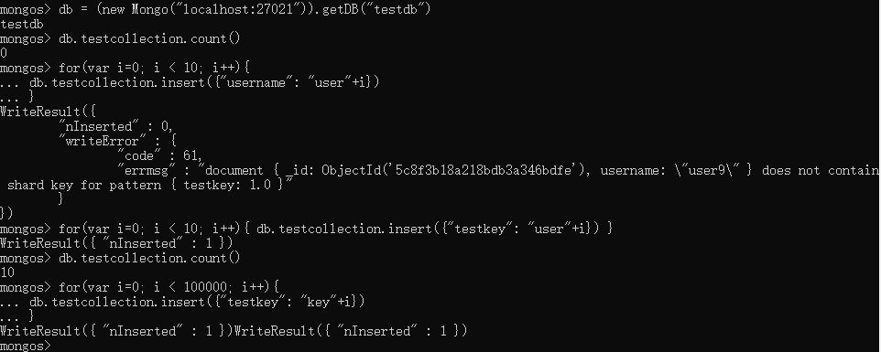

8. Check the shard status (after populating data)

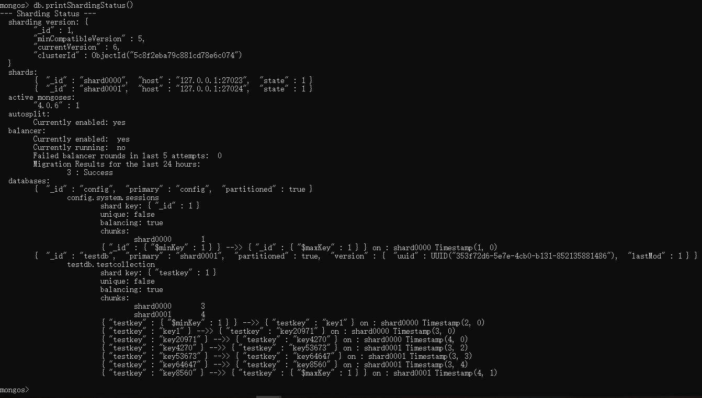

9. Connect to the shards and see how many documents are stored in each shard.

mongo 127.0.0.1:27021

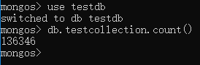

mongo 127.0.0.1:27023

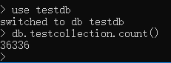

mongo 127.0.0.1:27024

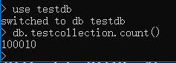

13634 = 36336 + 10010

9. Adding a new shard to the cluster

Make a directory and launch mongod for the shard 2

Sudo mkdir -p /db/shard2/data

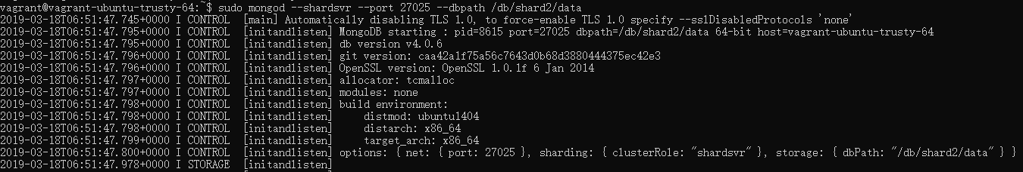

Add the new shard to the cluster. Connect to mongos and addShard.

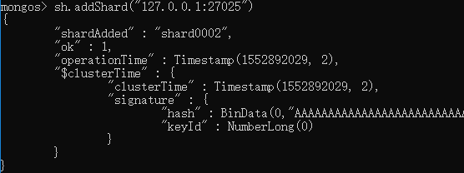

Check the shard status after adding shard 2.

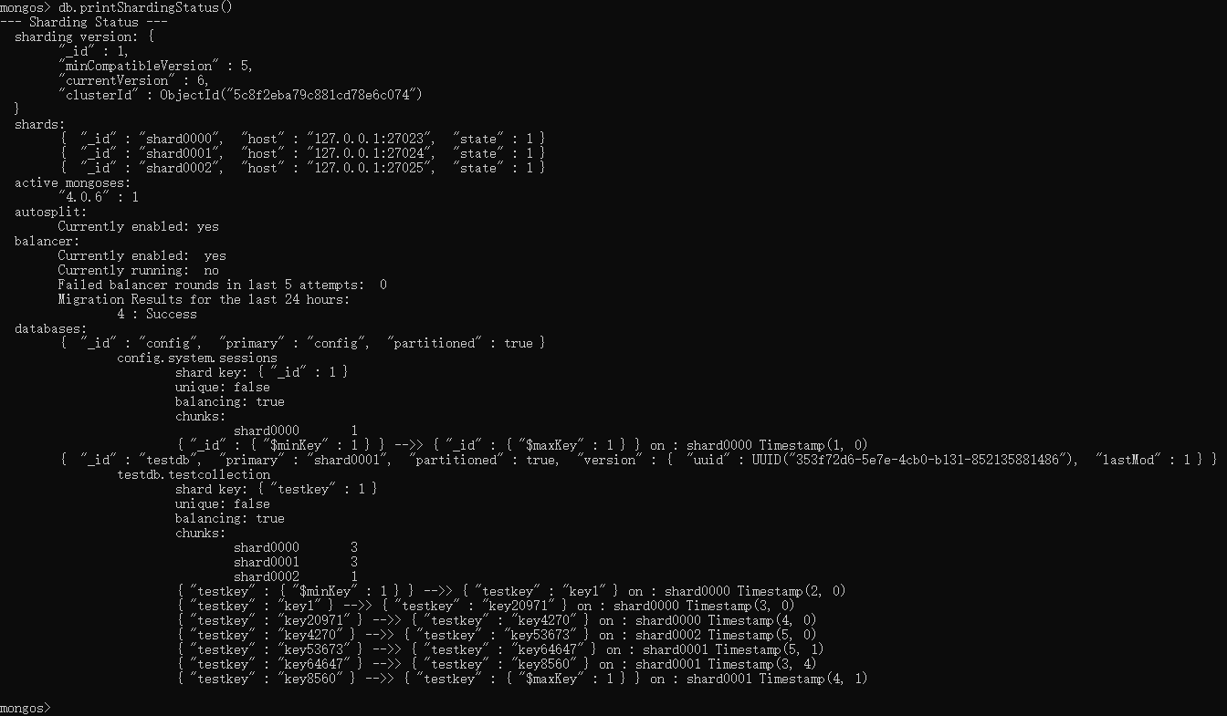

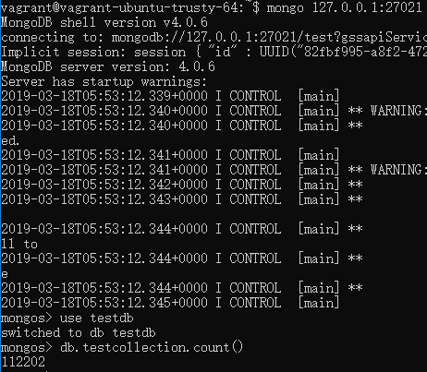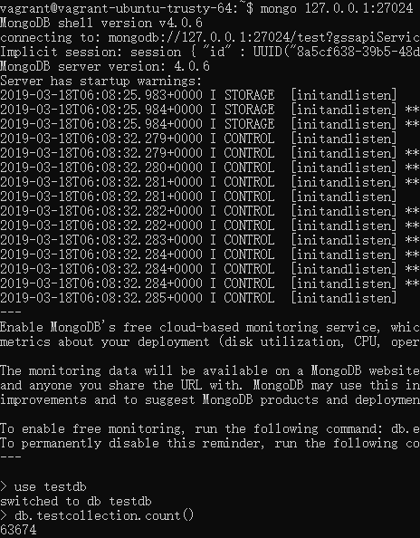

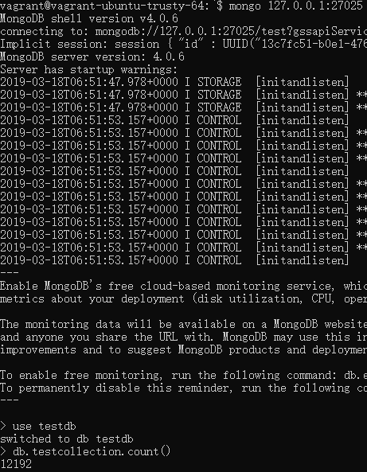

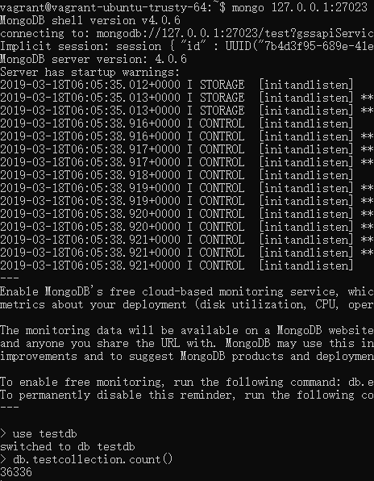

112202 = 63674 + 12192 + 36336

10. **Removing a shard from the cluster**

